**Nicky Lawrence CV**

**Email: nicky@nickylawrencejewellery.co.uk**

**Instagram: @nickylawrencejewellery**

**Website:** [**www.nickylawrencejewellery.co.uk**](http://www.nickylawrencejewellery.co.uk)

I make wearable and non-wearable sculptures in glass and metal. My work is inspired by the coral reef. Working in glass enables me to reflect both on the beauty and the fragility of the reef.

Nudibranch on coral reef

|  |  |
| --- | --- |
| **Publications**  2020  2020  2019 | Association for Contemporary Jewellery (ACJ) article, ‘**Nicky Lawrence Glass and Copper’** in Findings  **Transition spotlight Nicky Lawrence** on Goodfellows’ Material Hub  Nudibranch Jewellery  featured in  Mirka Janeckova's book, **'Designing and Making Glass Jewellery'**. |
| **Film** 2021 | Vimeo about my work for World Craft Town, Farnham |
| **Podcast** 2021 | Podcast about my work for Goodfellow podcast, ‘The Materials Inside’ |
| **Exhibitions:**  2023  2022  2021  2021  2021  2019 – 2020  2020  2019  2019  2019  2019  2018  2018  2017 | **Transition-Brighton**, Gallery40, Brighton  **‘Materiality’**, Oxo Tower Gallery, London  **Continuum**, Oxo Tower Gallery, London  **‘Life Forms’**, Pyramid Gallery, York  **Association for Contemporary Jewellery (ACJ) Annual Exhibition** (on line)  **‘Connections/Connessioni**:’ Goldsmiths' Centre;  The Lighthouse,  Glasgow; Livorno and Padova, Italy  **‘Another Brick in the Wall’**, Artists in Residence Exhibition, Farnham  **Transition-Chichester**,  Ox Market Gallery, Chichester  **Artists in Residence** Exhibition,  Foyer Gallery, UCA Farnham  **'Refined Elements'** featuring Calder Plus Collection, London Glassblowing  **Transition-Henley**, Old Fire Station Gallery, Henley  **Transition MA show**,  Espacio Gallery, London  **MA Show**,  James Hockey Gallery, Farnham  **Synergy II’**,  London Glassblowing Gallery, in collaboration with Layne Rowe |
| **Residences &**  **Internships**  2018-2020  2017  2017 | Artist in Residence, University for the Creative Arts, Farnham  London Glassblowing - 1 week work experience  Koru Arts (Glass studio) - 3 week internship |
| **Collaborations**  2017 | Collaboration with **Layne Rowe**, glass blower at London Glassblowing to make the ‘Calder Plus’ jewellery collection for Synergy II exhibition. |
| **Artists’ groups** | **Making Matters** (Artists’ group running community art projects & art & craft pop-up shops (www.making-matters.co.uk)  **Transition** (MA artists’ group) (www.transitioncraftdesign.co.uk)  **Continuum** (MA artists’ group) (www.craftcontinuum.com) |
| **Memberships** | Association for Contemporary Jewellery (ACJ)  The Contemporary Glass Society (CGS) |
| **Education**  2016-2018  1995-1998  1982-1986 | **MA** in Jewellery (glass and metal) (Merit)  *University for the Creative Arts, Farnham, UK*  **MSc** in Environmental and Development Education (Distinction)  *South Bank University, UK*  **BA** Honours Degree in Modern Languages (2.1)  *Cambridge College Arts and Technology, UK* |

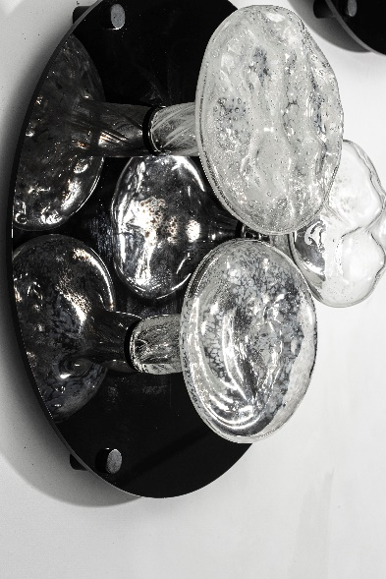

'Vertical Reef' - blown glass coral reef